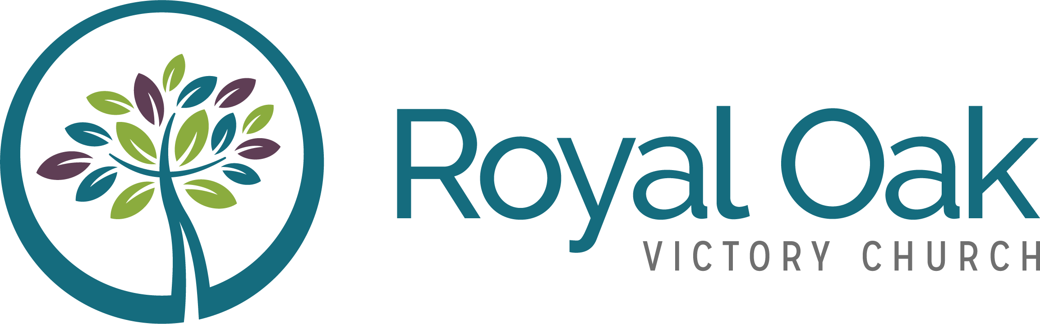

Social media Plan
Prepared by Joe Viergutz
October 24, 2017

Table of contents

Table of contents 2
Goals 3
Engagement ideas 3
General 3
Tracking engagement 4
Editorial calendar (Example) 4
Recommendations 4
Christmas event engagement tracking 5
Appendix A: Ways to use Instagram 6

Goals
The primary goal of this plan is to create meaningful experiences that encourage participation from Royal Oak Victory Church’s existing audience on a weekly basis by involving them during the sermon, engage in discussions on Facebook and Twitter, as well as get them involved outside of church.

The secondary goal is to increase the number of followers/likes across social channels.

Engagement ideas

You Version (Bible App) Event
- Post announcements
- Ask for prayer requests
- Add sermon notes
- Take notes
- Link to anything on the web
- Poll Users
- Give people questions to think about during the week
- Recommend reading plans/devotionals

General

- Ask applicable questions on Twitter during the sermon
- Do a poll on Twitter/Facebook
- Do Facebook exclusive video clip (like a blog post)
- Behind the scenes photos/video(s)
- Do Q&A sermons
- Curate and share content
- Share inspirational quotes/images/stories
- Photo Caption contest
- Ask people to share their stories through the website
- Create blog post from sermon for website

Tracking engagement
- Google analytics (website)
- Facebook/Twitter/YouTube/Instagram stats
  - Likes
  - Comments
  - Shares
  - Retweets
  - Facebook reactions
  - Video Views
  - Average view duration
  - Number of clicks

- Attendance growth
- Word of mouth
- Advertising on social (Facebook, Instagram)
- Boosting posts
- Put a “how did you hear about us?” section on the connect card

Editorial calendar (Example)

Sermon series | Sermon name | Post Date | Channels | Images
Born for this | Born with a Name | October 10 | YouTube, Facebook, Twitter, Instagram | Sermon image

Recommendations

In addition to YouTube, Facebook and Twitter, ROVC should also incorporate Instagram in their social strategy. Quality is more important than quantity.

- Promote the live stream
- Post to social accounts when users are the most active on Twitter which is between 9:00 am and 11:00 am and 5:00 pm and 7:00 pm.
- Fill out about section on YouTube
- Promote “Share your story” on website

Christmas event engagement tracking

            - Record number of likes/shares/comments in spreadsheet
            - Boost post on Facebook
            - Use Instagram ads
            - Use Facebook pixel

Example Instagram post for Christmas series

Appendix A: Ways to use Instagram

- Introduce staff members
- Promote service times
- Advertise sermon series
- Show newcomers what the service looks like
- Share testimonies from your congregation (link to story on website or tell the full story on Instagram)
- Share encouragement
- Promote upcoming events
- Show ways to get involved
- Provide sharable invite cards
- Showcase various ministries
- Share worship set list
- Share quotes from sermon
- Show what’s happening in the kid’s ministry
- Highlight outreach opportunities
- Share images of water baptisms
- Set up photo booth in the lobby

See appendix A for ideas
The Facebook pixel is an analytics tool that allows you to measure the effectiveness of your advertising by understanding the actions people take on your website.

